ET0104

ECS Project

Overall Report

Done by:

Poh Boon Siong

Lau Yue Hang

Contents

|  |  |  |  |
| --- | --- | --- | --- |
| **Table of Contents** | | | **Page** |
| **1. Introduction ------------------------------------------------------------------------------** | | | **3** |
| **1.1** | Overall System Description | |  |
| **1.2** | Challenges of the Project | |  |
| **2. User Manual -----------------------------------------------------------------------------** | | | **4** |
| **2.1** | Drink Selection | | 5 |
| **2.2** | Temperature Option | | 6 |
| **2.3** | Sugar Option | | 7 |
| **2.4** | Milk Option | | 8 |
| **2.5** | Preparation and Completion | | 9 |
| **3. Use case 1 – Select drinks with sugar and milk options -----------------** | | | **10** |
| **3.1** | | Use Case Diagram | |
| **3.2** | | Interaction Diagram | |
| **4. Use case 2 – Select drinks with temperature option -----------------------** | | | **11** |
| **4.1** | | Use Case Diagram |  |
| **4.2** | | Interaction Diagram |  |
| **5. Work Assigned --------------------------------------------------------------------------** | | | **12** |

1. **Introduction**
   1. **Overall System Description**The system we chose is a drink dispenser. The drink dispenser aims to guide the user through 9 different drinks, which are as follows:

* Nespresso
* Lipton Tea
* Nestle Milo
* Cadbury Hot Chocolate
* Milk
* Starbucks Coffee
* Orange Juice
* Water
* Ovaltine

Other than the drink selection, the drink dispenser allows the user to customise the drink. For example, if the user selects Nespresso, the user can choose the amount of sugar to be added, and an option for adding milk or not.

* 1. **Challenges of the Project**  
     One challenge that we encountered is that we had to create Graphical User Interface (GUI) that simple to use, without prior knowledge of how to create one. Through inspirations and tutorials online, we managed to create one that meets the requirements:  
       
     A screenshot of a computer

     AI-generated content may be incorrect.

1. **User Manual**
   1. **Drink Selection**

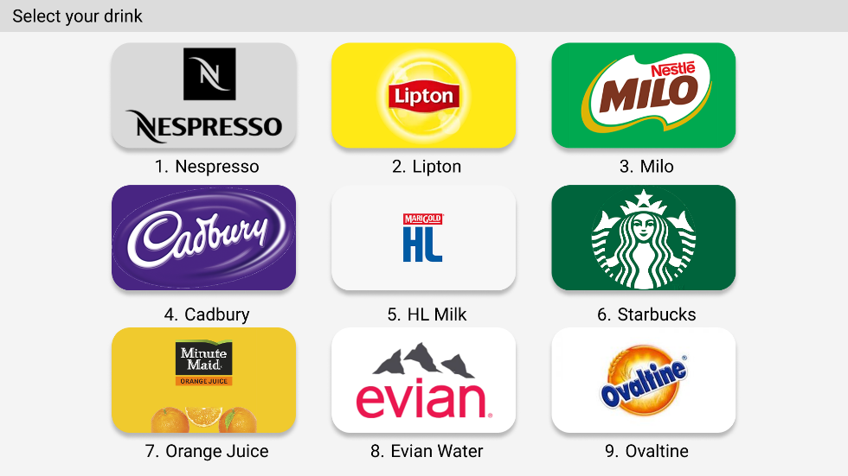

The program will display drink selection page upon launching. The user can choose 9 different drinks, ranging from coffees, hot chocolate, tea, to orange juice.

The LCD will also request the user to select a drink. To select a drink, press the number on the keypad to the corresponding number below each drink. The table below shows the corresponding number to press for each drink:

|  |  |
| --- | --- |
| Drink | Number |
| Nespresso | 1 |
| Lipton | 2 |
| Milo | 3 |
| Cadbury | 4 |
| HL Milk | 5 |
| Starbucks | 6 |
| Minute Maid Orange Juice | 7 |
| Evian Water | 8 |
| Ovaltine | 9 |

The program will then ask the user to confirm the selected drink as described in the image below, either press the same number again to confirm the selected drink, or press ‘0’ to cancel the selection, and return to the drink selection page. Once selected, the selection cannot be cancelled any more.

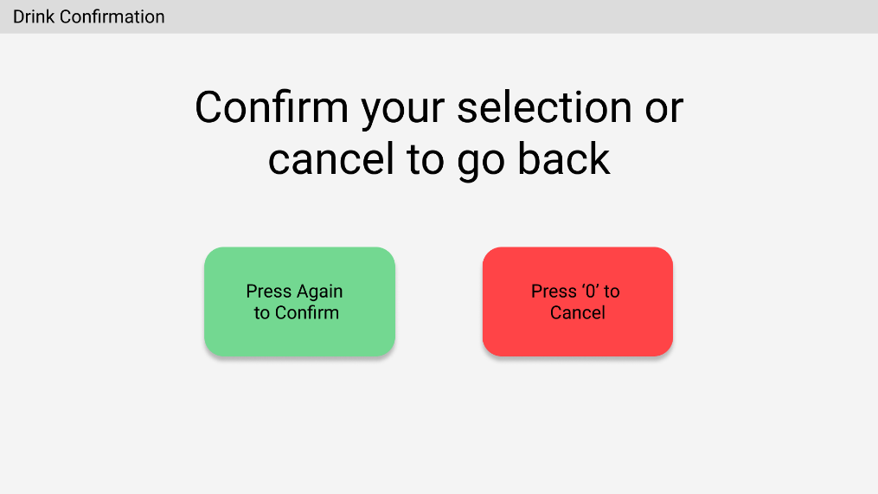

The LCD will also request the user for confirmation as shown in the next image:

After this, the program will either prepare the drink, or it will request the user to customise the drink depending on the type of drink selected. Below shows a table of the drink and the customisable options:

|  |  |  |  |
| --- | --- | --- | --- |
| Drinks / Options | Temperature  Option | Sugar  Option | Milk  Option |
| Nespresso | O | P | P |
| Lipton | O | P | P |
| Milo | O | O | O |
| Cadbury | P | O | O |
| HL Milk | P | O | O |
| Starbucks | O | P | P |
| Orange Juice | O | O | O |
| Evian Water | P | O | O |
| Ovaltine | O | O | O |

* 1. **Temperature Option**

The temperature option only applies to the following drinks:

* Evian Water
* HL Milk
* Cadbury

The program will ask the user to select the temperature of the drink. There will be 3 options to choose from as shown above image:

* Hot
* Cold
* Normal (Ambient Temperature)

LCD will display the corresponding numbers to press, relating to each temperature option, as shown below:

To choose the temperature for the drink, press the number on the keypad to the corresponding number below each temperature option. The table below shows the corresponding number to press for each drink:

|  |  |
| --- | --- |
| Temperature Option | Number |
| Hot | 1 |
| Cold | 2 |
| Normal (Ambient Temperature) | 3 |

* 1. **Sugar Option**

Similarly to the temperature option, the sugar option only applies to selected drinks which are:

* Nespresso
* Lipton
* Starbucks

Once either one of the drinks from above are selected and confirmed, the program will first ask to choose the amount of sugar to be added to the drink. There are 3 options that the user can select from:

* No Sugar
* Less Sugar
* Normal

The LCD will show the available sugar option as shown in the image below:

Same as temperature option, to choose, simply press the number on the keypad that corresponds to the number below each option. Once the option has been selected, the program will then request the user to choose whether to add milk to the drink. Details will be explained in the next section. The table below shows the corresponding number for the sugar option:

|  |  |
| --- | --- |
| Sugar Option | Number |
| No Sugar | 1 |
| Less Sugar | 2 |
| Normal | 3 |

* 1. **Milk Option**

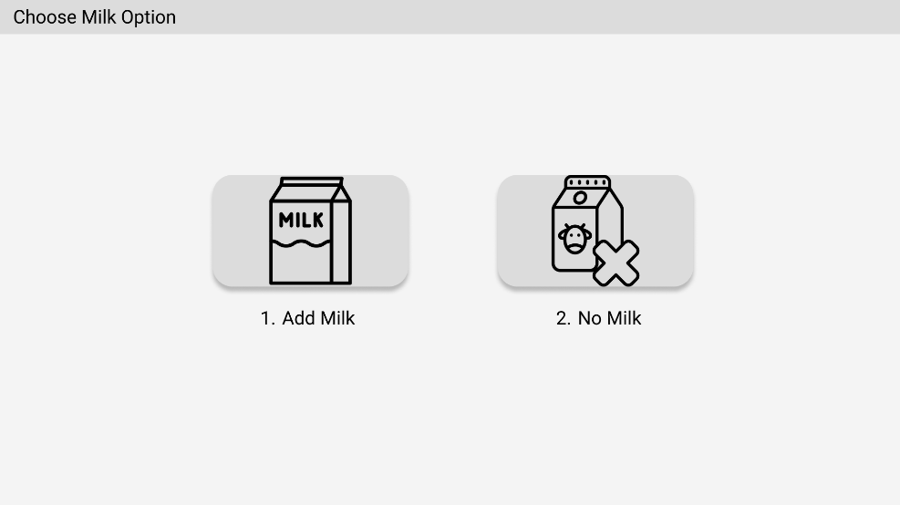

As mentioned in the previous section, the milk option is requested after the sugar level is selected. Thus, it is only applied to the same drinks as the sugar option. Once the sugar level is selected, the program will then request the user to select one of the following:

* Add Milk
* No Milk

Similar to other options, the LCD will display a request to add milk, and the corresponding number to press for each of the option as shown below:

To select the option, the user has to use the keypad to key in the number that corresponds to the number below the option. Below is a table that shows the number to press for each option:

|  |  |
| --- | --- |
| Milk Option | Number |
| Add Milk | 1 |
| No Milk | 2 |

* 1. **Preparation and Completion**

Once the drink has been confirmed or customised finish, the program will prepare the drink. The above image will be shown to indicate that it is preparing. Please wait for 7 segment display to count finish, and until the screen shows that it is completed, which is as shown below:

The LCD will also show a confirmation that the drink is ready:

Once it is completed, the program will wait for a while, and it will return to the drink selection page.

1. **Use case 1 - Select drinks with sugar and milk options**
   1. **Use Case Diagram**

* 1. **Interaction Diagram**

1. **Use Case 2 - Select drinks with temperature option**
   1. **Use Case Diagram**

* 1. **Interaction Diagram**

1. **Work Assigned**

Below is a table of the worked assigned to each team member

|  |  |
| --- | --- |
| Lau Yue Hang | Poh Boon Siong |
| * Designed and coded the program   + System design   + Keypad   + LCD   + Motor   + 7-Segment Display   + Logic * Designed the UML for Use Case 1 | * Designed the GUI for the program * Designed the UML for Use Case 2 * Created the User Manual * Helped to debug some of the parts of the program |